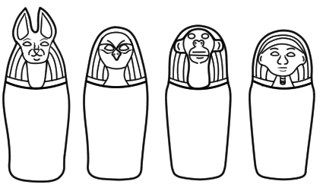The Canopic Jars of Pharaoh _________________________